1. Create a separate namespace to segregate all elastic search related pods

***kubectl create namespace elasticsearch***

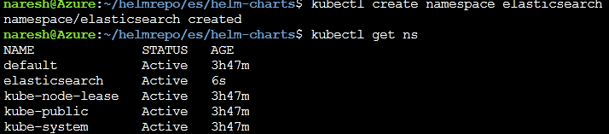

1. Download ES helm charts

<https://github.com/elastic/helm-charts>

1. Update elasticsearch/ values.yaml file under the helm charts

service.type=LoadBalancer

nodePort=32130

1. Install elasticsearch using helmcharts

***helm install elasticsearch elasticsearch/ --namespace=elasticsearch***

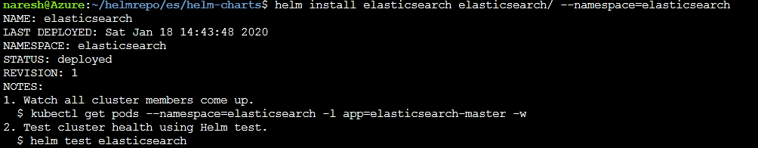

Login to pod and verify endpoints

***kubectl exec -it elasticsearch-master-0 /bin/sh -n elasticsearch***

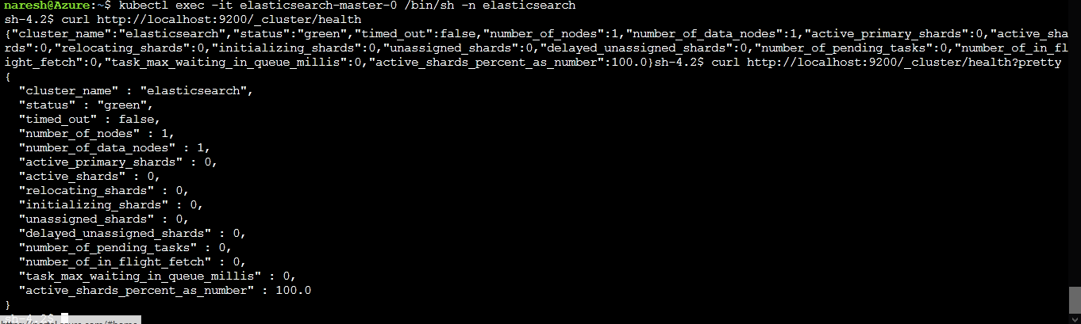

Verify elastic search services



Access elastic search from browser using LoadBalancerIP address

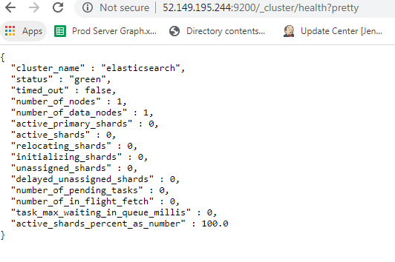

Update kibana/values.yaml file

**service.type=LoadBalancer**

**elasticsearchURL=”<es url>”**

Install kibana using helm charts

***helm install kibana kibana/ -n elasticseach***



Access kibana from browser

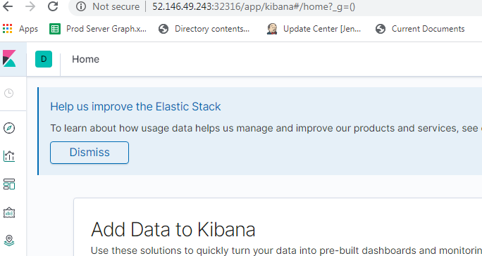

Insert data using Kibana API

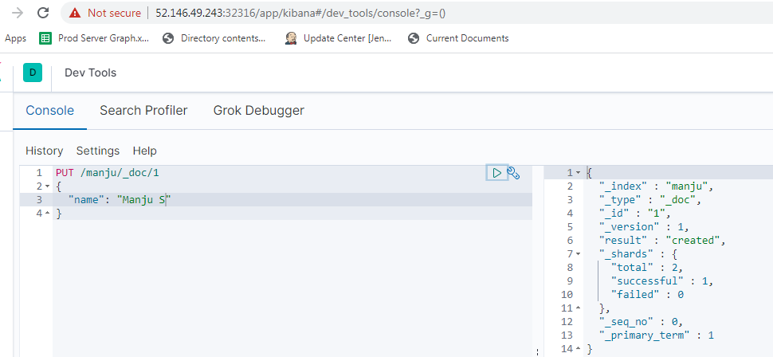

Verify indices using elasticsearch url

